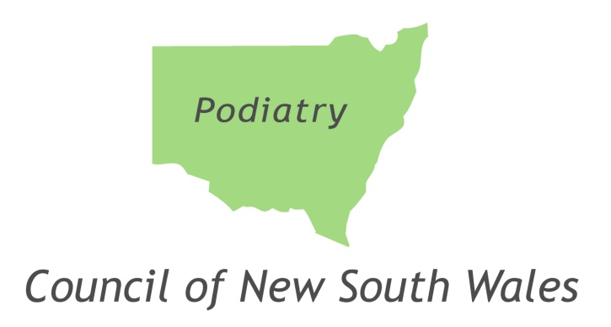

Mentor Approval Position Statement

Date of publication: | August 2015 |  |  | File Number: HP15/8631 | -
Version: | Version 1
Summary: | This position statement sets out the criteria the Podiatry Council of NSW applies when considering approval of a mentor and the Council’s expectations of an approved mentor.
Applies to:  Of Interest to: | Practitioners subject to mentor conditions, mentors, delegates of the Podiatry Council of NSW and HPCA staff supporting the Podiatry Council of NSW.  Decision makers
Author: | Podiatry Council of NSW
Owner: | Podiatry Council of NSW
Related legislation:  Related Policy:  Related(other):  Review date: | Health Practitioner Regulation National Law (NSW)  Complaint Policy – Mentoring  Conditions Handbook – Template Conditions  August 2018
Mentor Approval Position Statement

This position statement sets out the criteria the Podiatry Council of NSW applies when considering approval of a mentor and the Council’s expectations of an approved mentor. It should be read in conjunction with the Council’s Compliance Policy - Mentor, which sets out the obligations of a practitioner subject to mentor conditions.

PURPOSE
Mentor conditions are intended to facilitate the development of a relationship between the practitioner and a respected experienced practitioner in the same/similar area of practice, who acts as a support person for the practitioner. A mentor may provide assistance with professional and personal development, and help a practitioner to cope in the professional environment in which he/she may have had some difficulties, or from which he/she may have been absent for some time.

The Council expects a practitioner subject to mentor conditions to ensure that his/her practice (or specified aspects of their practice) is guided by a mentor approved by the Council.

ROLE OF A MENTOR
By consenting to act as a Council-approved mentor, a mentor agrees to act as a support person for the practitioner, assisting with their professional and personal development. Mentors are expected to have regular communications with the practitioner, such as telephone conversations and/or face-to-face meetings and to be generally available to discuss issues relating to clinical practice or any other matters that may arise.

The role of the mentor is to be distinguished from that of a supervisor. Whilst both mentors and supervisors act in the public interest, a mentor is expected to be a source of support for the practitioner, while a supervisor essentially acts for the Council.

Owing to the supportive nature of a mentoring relationship, the Council will not usually intervene. The mentor should however, inform the Council immediately if he/she has any concerns about the practitioner, the mentoring relationship, or if he/she is unable to continue in the role.

WHAT INFORMATION A MENTOR RECEIVES
As part of their briefing, mentors will receive publicly available information that is relevant to the practitioner being mentored.
Other information may be provided, depending on the constraints of confidentiality in each particular case.

NATURE OF A MENTORING RELATIONSHIP
Effective mentoring usually depends upon the creation of a trusting relationship with open and honest communication between the practitioner and the mentor.
Guidance and support can be incorporated into a mentoring relationship in many ways, including:

- Discussion of the personal and professional impact on the practitioner of the issues which brought him/her to the attention of the Council.

- Discussion of work related problems and solutions.

- The opportunity to discuss issues with an objective colleague.

- Discussion about participation by the practitioner in continuing education and professional groups and activities.

CRITERIA FOR APPROVING A MENTOR
The following criteria will be taken into account when considering whether to approve a mentor:
- A mentor should be an experienced practitioner in a relevant area of practice.
- A mentor:
  - Should be a registered Podiatry practitioner and be in active clinical practice;
  - Should not be the subject of current investigation, assessment, inquiry or proceedings in relation to conduct, health or performance matters;
  - Should not have conditions imposed on his/her registration, and
  - Should not have been the subject of an adverse finding in previous disciplinary proceedings, regardless of whether or not his/her registration remains subject to conditions.

- The mentor should not be involved (in a material way) in the subject matter which gave rise to the imposition of mentor conditions.

- Mentors must consent to undertaking the role of mentor.

- The mentor must indicate that they are prepared to provide feedback to the Council, in a prescribed format (template provided by the Council) and at the frequency prescribed by the mentoring condition.

- A mentor must be prepared to notify the Council of any immediate concerns in relation to the practitioner’s compliance with the mentorship requirement, or in relation to the practitioner’s conduct, performance or health, or if the mentorship ceases.

- The relationship between the mentor and the practitioner should be at a purely professional level:
  - A mentor must not be a relative, partner or close friend of the practitioner;
  - A mentor must not be the practitioner’s Council-approved supervisor;
  - Consideration will be given to relationships that might impact on the mentor’s ability to mentor the practitioner. Examples of such circumstances may include:
- Relationships where there is a close social interaction;
- Treating relationship;
- Power imbalance within the relationship;
- Financial/business relationship, and
- Employment relationship.

Nominees who do not meet these criteria may not be approved.

The Council may withdraw a mentor’s approval where a mentor ceases to meet the criteria set out above, or at any time at its discretion.

IMPLEMENTATION OF THE POSTION STATEMENT
This Position Statement will be published on the Council’s website, provided to practitioners when mentor conditions are imposed, and provided to nominee mentors. It should be read in conjunction with the Council’s Compliance Policy - Mentor.

ACKNOWLEDGEMENT
The Podiatry Council acknowledges that this Position Statement, the Mentoring Policy Statement and Mentoring Conditions were adapted from versions prepared by and for the Medical Council of New South Wales and that the Medical Council has granted permission for their adaptation by other health professional councils.

Nominated Mentor Consent Form

Please return completed form with a brief CV to the Podiatry Council of NSW
Email: mail@podiatrycouncil.nsw.gov.au

Name AHPRA Registration Number

Please strike out the option that does not apply:

- I accept / do not accept Mr/Ms/Mrs {Surname}’s nomination of me as [his/her] mentor

If you accept, please complete the following:

2. I have read the Podiatry Council of NSW’s Compliance Policy – Mentor, Mentor Approval Position Statement, and believe I meet the requirements to mentor Mr/Ms/Mrs {Surname} in accordance with this Policy and condition/s [X].

3. I will immediately notify the Podiatry Council if I have any concerns about Mr/Ms/Mrs {Surname}’s compliance with conditions, or Mr/Ms/Mrs {Surname}’s conduct, performance or health, or if the mentorship ceases.

4. I am a registered Podiatry practitioner (please answer the following questions):

- Are you in active clinical practice? Yes / No

- Are you the subject of current conduct, health or performance
investigation(s) or proceeding(s)? Yes* / No

- Do you have any conditions imposed on your registration? Yes* / No

- Have you been the subject of an adverse finding in
previous disciplinary proceedings? Yes* / No

- Are you currently mentoring or supervising any other practitioners? Yes* / No

- Are you aware of any relationship/association with Mr/Ms/Mrs
[Surname] that may impact on your ability to supervise him/her
(see Criteria 7 in Approval Statement)? Yes* / No

* Please provide further details if you answered Yes to questions (b), (c), (d), (e) or (f).

5. I wish to make a submission. (Optional)

6. I have enclosed a copy of my CV. (Required)

Signed: _________________________ Date: _________________

Name: | Address:  Phone::
Position:

AHPRA Registration Number:

Email Address:

